1. A screenshot of Visual Studio Code showing app.py from the Activity 11.4.zip file.

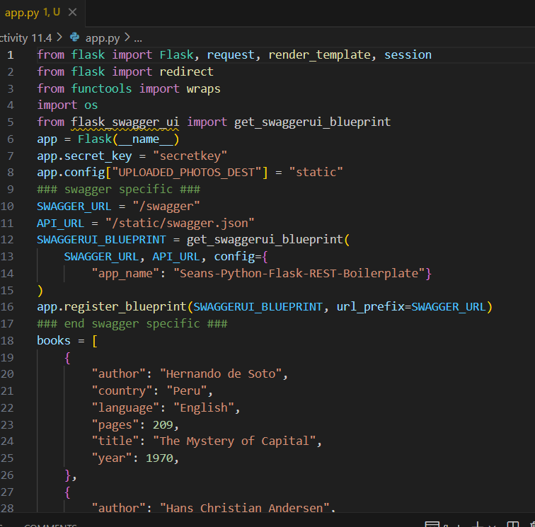

1. A screenshot of the web browser pointing to “http://localhost:5000” and showing the application running.

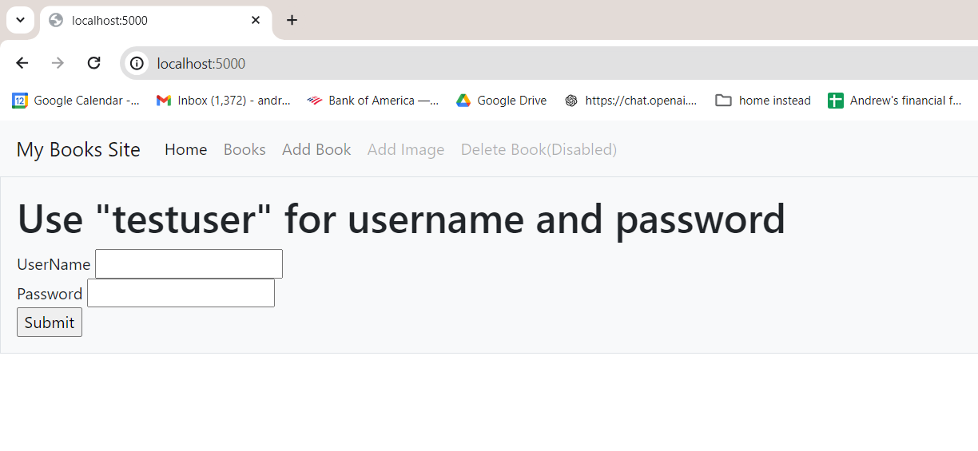

1. A screenshot of the browser pointing to “<http://localhost:5000/swagger>”.

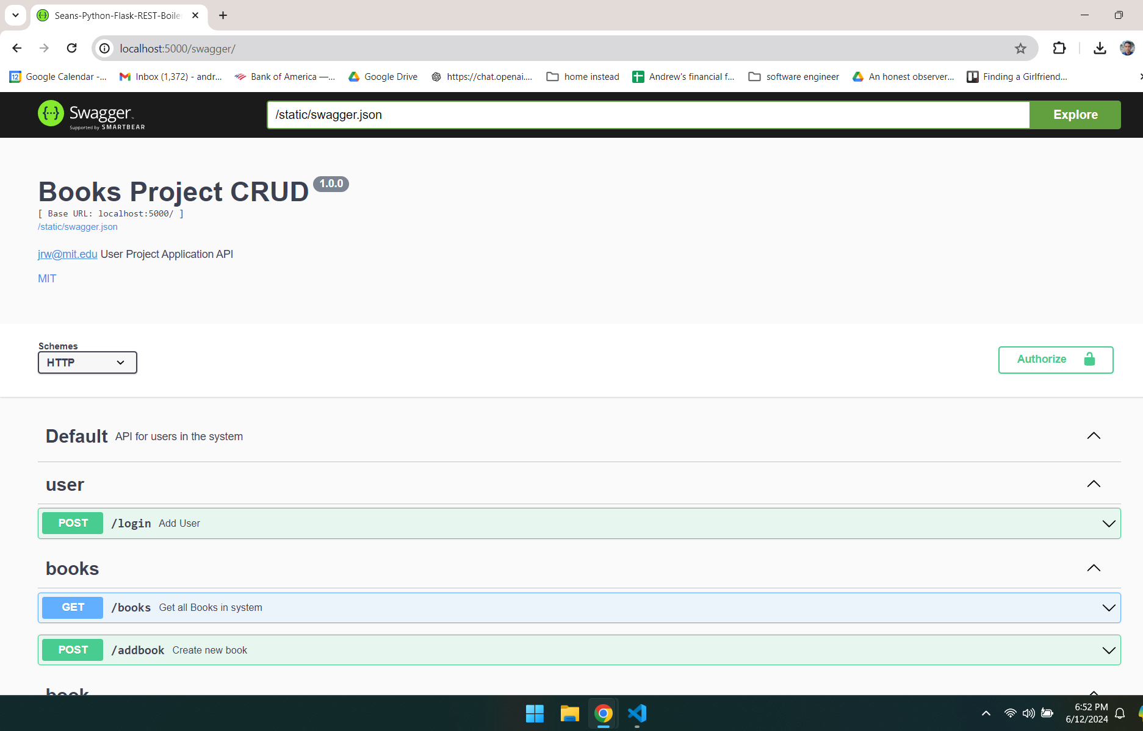

1. A screenshot of the call to GET *method* to get books, including output. (before doing this, need to log in first)

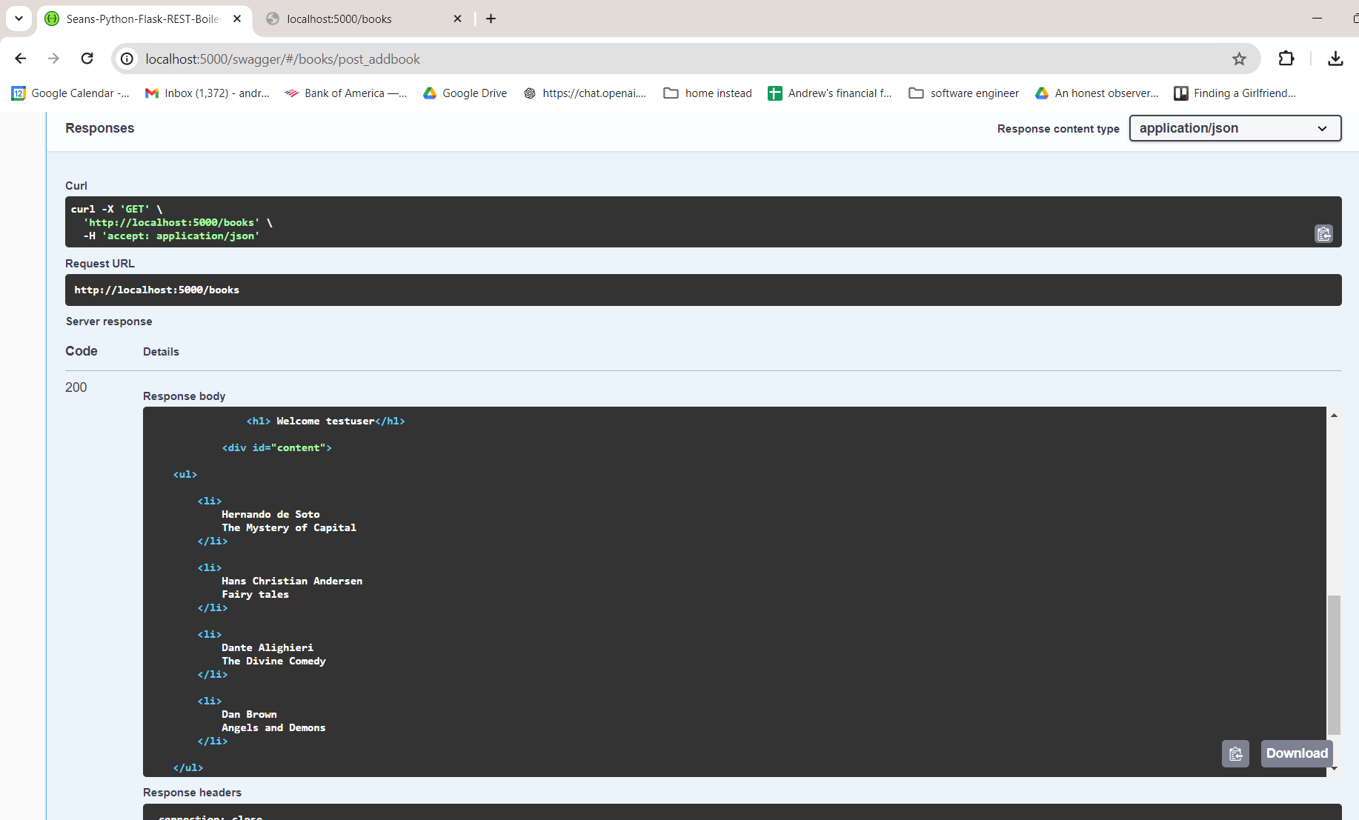

1. A screenshot of the call to POST *method* to create a book, including output.

